**1.**

select ID, count(course_id)

from instructor natural left outer join teaches

group by ID;

**2.**

select ID, (select count(course_id)

from teaches

where teaches.ID=instructor.ID) as num_of_course

from instructor;

我们来看为什么2这条Unrelated Subquery可以和1的left outer join等价

instructor teaches

|  |  |
| --- | --- |
| ID | inst_info |
| 1001 | i1 |
| 2002 | i2 |
| 3003 | i3 |

|  |  |
| --- | --- |
| ID | teach_info |
| 1001 | t1 |
| 1001 | t2 |
| 1001 | t3 |
| 2002 | t4 |
| 2002 | t5 |

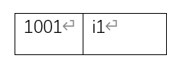

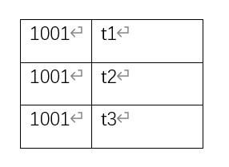for each Row **row_inst** of instructor: // from instructor

if teaches.ID = **row_inst**.ID: // where teaches.ID=instructor.ID

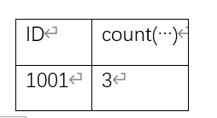 count(…)

最终得到

|  |  |
| --- | --- |
| ID | count(…) |
| 1001 | 3 |
| 2002 | 2 |
| 3003 | 0 |